Instruction for Use
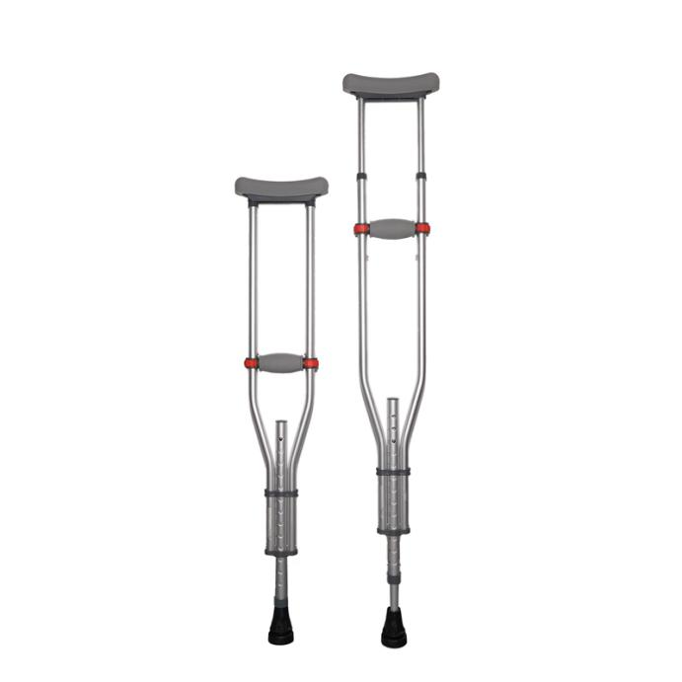

Common Examples of Use

Suit for patients who require support and stability after injuries such as fractures or ligament strains.

Suit for elderly or disabled individuals with mobility impairments, such as lower limb paralysis, stroke sequelae, etc.

WARNING:
This product should be given by an treating doctor and applied by a professional. Application should be done with great care to ensure correct fit and efficiency of the brace. For hygiene reasons, it is proposed to be used by a single patient. Recommended product use up to 2 years.

WASHING INSTRUCTIONS:
Check the condition of the product before use. If it is worn off, it needs replacement.
Hand wash with cold water. Use a soft detergent and remove the pads.
Allow to dry on its own. Do not wash it in a washing machine or dry it in a tumble dryer.

